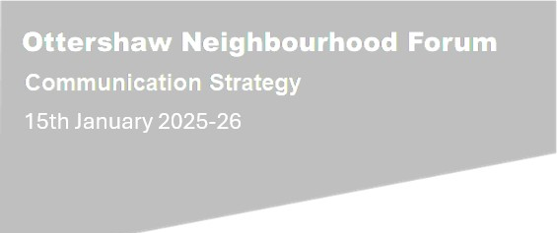





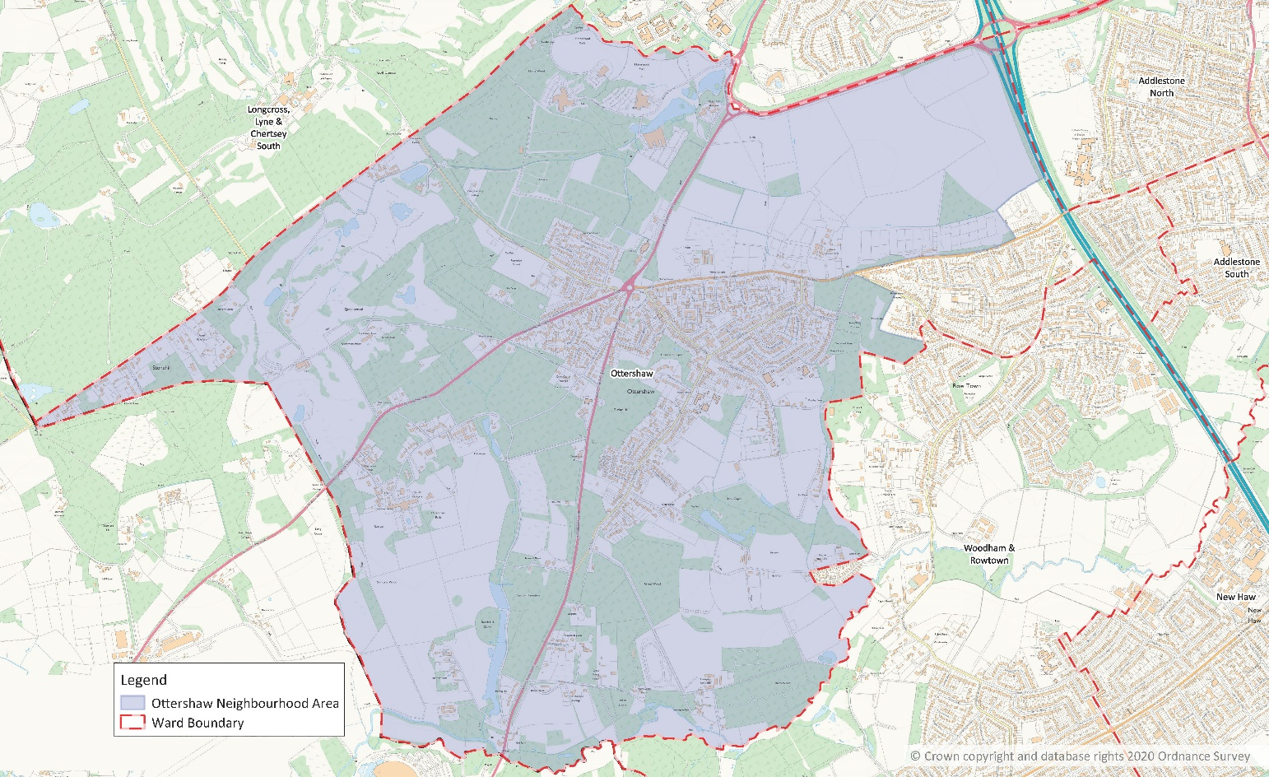

Table of Contents

Table of Contents i

1 Introduction 1

2 Purpose 2

3 Objectives & Goals 3

3.1 Objectives 3

3.2 Goals 3

4 Target Audience 4

5 Key Messages 5

6 Communication Methods 8

7 Communication Plan (COVID sensitive activities only assumed until June 2021) 10

# Introduction

At the meeting on 14th October 2020, the Runnymede Borough Council Planning Committee received applications for the designation of an Ottershaw Neighbourhood Forum and an Ottershaw Neighbourhood Area as permitted under the Localism Act 2011 following the required period of public consultation.

The Neighbourhood Forum application was considered to fully meet the conditions set out within the relevant Act of parliament and associated regulations. The geographical extent of the proposed Neighbourhood Area was also considered appropriate and compliant with relevant regulations.

The Planning Committee supported the designation of the Neighbourhood Area and Forum as proposed.

IT WAS RESOLVED that:

i) The Ottershaw Neighbourhood Area be designated; and

ii) The Ottershaw Neighbourhood Forum be designated to cover the area.

At the first meeting of the Neighbourhood Forum Steering Committee it was agreed that a comprehensive Communication Strategy should be developed with the objective of reaching 80% of the residents in the Neighbourhood Area.

Due to the importance of the Communication Strategy the Vice Chair of the Forum was tasked with the role of Communications Co-ordinator with the following responsibilities:

* To develop a communication strategy and plan which includes:
  + The full range of applicable segments (Youth, Businesses, etc)
  + The definition and scope for use of social media (e.g. Facebook, Twitter, Instagram), website, newsletters, leafletting, face to face meetings, press liaison, member communication, etc
  + Content Management across all media and platforms.
  + Engagement within and beyond our Neighbourhood area.
  + Key stakeholders including:
    - Residents
    - Local businesses
    - Local societies
    - Local community groups
    - Local landowners
* To establish working group(s) to develop and execute the tasks prescribed in the Strategy & Plan.
* To maintain content across all media platforms to ensure appropriateness and coherence.

# Purpose

This Communication Strategy has been developed in order to:

* Raise awareness and understanding of the emerging Ottershaw Neighbourhood Plan (“**ONP**”) throughout its development, in particular how we will manage and communicate the key messages and content of the **ONP** to identified stakeholders and target audiences.
* Provide the Steering Committee, Runnymede Borough Council and other stakeholders with a documented framework detailing which communication mechanisms would be most appropriate for the target audiences.
* Ensure the communication of issues, relevant information and project updates to Key Stakeholders.
* Provide mechanisms for seeking and acting on feedback to encourage the involvement and raising awareness of the ONP to Stakeholders.
* With respect to the Plan to identify the actions required for the successful implementation of the strategy and associated costings.

**The review date for this document is January 2026**

# Objectives & Goals

## Objectives

Implementation of this Communication Strategy will:

* Aim to maximise the publicity of the Ottershaw Neighbourhood Forum and Neighbourhood Plan to facilitate maximum input from the population of the Ottershaw Area.
* Ensure the gathering of the wishes of the community.
* Aim to influence local decision making.
* Ensure communication between all relevant organisations and entities regarding the activities and plans associated with the Ottershaw Neighbourhood Area.
* Ensure positive community engagement.
* Ensure the achievement of the objectives of the Ottershaw Neighbourhood Forum.
* Aim to increase the size, scope and profile of the Forum membership.
* Ensure transparency & democratic procedures are observed.

## Goals

Implementation of this Communication Strategy will:

* Achieve the goal of reaching 80% of the residents in the Neighbourhood Area.
* Through a process of continuous engagement with the residents of the Neighbourhood Area to ensure the ONP reflects their wishes and achieves a successful referendum.

# Target Audience

The target audience is:

| **Stakeholder(s)** | |
| --- | --- |
| **Residents** | * <18yrs * 18–24 yrs * 25–44 yrs * 45–59 yrs * 60-75 yrs * Over 76 yrs |
| **Community, Clubs & Groups** | * Sports * Social (friends) * Cultural * Heritage * Faith Based * Youth * Schools/Pre Schools * Learning Needs * Physical Needs * Travellers * Other |
| **Landowners** | * Local Landowners * Developers * Local Authorities |
| **Business** | * Retail * Agricultural Tenant * Other |
| **Statutory Consultees / Supporting**  **Organisations** | * Runnymede Borough Council * Groundwork (Grant Funding) * Locality (NP Support) |
| **Politicians** | * MP * County Councillor * Ward Councillors |
| **Neighbours** | * Wards * Boroughs * Adjacent Area Neighbourhood Forums |

# Key Messages

The following key messages need to be applied, consistently, throughout the communications activity.

|  |  |
| --- | --- |
|  | **Message** |
| 1 | The Forum and its emerging Neighbourhood Plan promotes a “village feel” |
| 2 | The Forum and its emerging Neighbourhood Plan support policies that help to ensure an environmentally sustainable, vibrant, and thriving community. |
| 3 | The Forum is made up of the Ottershaw Neighbourhood Area members working for the benefit of the whole area community. |
| 4 | The Forum and its emerging Neighbourhood Plan support new proportional developments that are in sympathy with the promotion of the village feel. |
| 5 | The Forum and its emerging Neighbourhood Plan seeks to protect against inappropriate and unwanted development. |
| 6 | The Forum and its emerging Neighbourhood Plan seeks to minimise the impact on the green belt, green corridors between built areas and the natural environment. |
| 7 | The Forum and its emerging Neighbourhood Plan reflect the wishes of its area residents. |
| 8 | The Forum operates democratically, openly and transparently. |
| 9 | The Forum supports and encourages community engagement. |

# Communication Methods

| **Key Tools** | **Notes** | **Frequency** | **By Whom** |
| --- | --- | --- | --- |
| Community Champions | The Community Champions should be ONF Members and volunteers who come from a wide cross-section of the community. They will use relevant other methods listed below to communicate. | When necessary throughout the process. | As selected by the Chair of the Comms WG |
| E-mail/letter | Direct engagement with specific individuals, businesses or groups | As required | Steering Committee & WG members |
| Face to Face Meetings (As COVID Permits) | Formal Forum meetings, Informal promotional events, ad hoc meetings | As required by the Forum, planning process or determined by the constitution. | As nominated by SC or WG Chairs |
| Website | A dedicated site with links to local websites & social media to reach a wide audience. | Updated regularly – at least monthly and immediately following any key events. | IT Coord  Content Managers  Comms WG |
| Social Media | Periodical media posts as required to reach a wide audience. | Updated following any key events. Regularly monitored. | Social Media Administrators  Content Managers  Comms WG |
| Community Events e.g. May Fair, School visits (as COVID Permits) | These will compliment work undertaken by the Forum. | If possible at least 1 event per year | Steering Committee & Chair Comms WG |
| Virtual Meeting (Zoom/Teams) | Alternative to face-2-face meetings | When necessary | Steering Committee & WG Chairs  Community Meetings |
| Press Releases | The use of press releases will allow regular progress updates and broadcast of key messages to the wider community. | When necessary | Steering Committee & Chair Comms WG |
| Newsletters | Periodical publication to provide current information regarding forum business and progress. E-Newsletters delivered via WIX | Monthly | Steering Committee & Chair Comms WG |
| Survey/Questionnaires | Online or hardcopy surveys hand delivered to local community. | When necessary | Steering Committee & Chair Comms WG |
| Leaflets/Posters/Banners | Can be distributed and put up in Village Hall & around the Neighbourhood Area, local libraries, local shops, businesses & other establishments. | When necessary | Steering Committee & Chair Comms WG |
| Status Reports/Briefings | Status reports | When necessary | Steering Committee & WG Chairs |

# Communication Plan

|  |  |  |  |  |  |  |  |  |  |  |  |  |  |  |  |  |
| --- | --- | --- | --- | --- | --- | --- | --- | --- | --- | --- | --- | --- | --- | --- | --- | --- |
| **Target Group** | **Aim** | **Tools** | **2025/26** | | | | | | | | | | | | | |
| **02** | **03** | **04** | **05** | **06** | **07** | **08** | **09** | **10** | **11** | **12** | **01** | **02** | **03** |
| Members/Associate Members | Engagement | Email/Zoom/Teams/ Face to Face |  |  |  |  |  |  |  |  |  |  |  |  |  |  |
| Residents Youth | Increase Membership | Social Media/Emails/  Face to Face |  |  |  |  |  |  |  |  |  |  |  |  |  |  |
| Residents Youth | Increase Membership | Visit Schools/Clubs |  |  |  |  |  |  |  |  |  |  |  |  |  |  |
| Residents Youth | Opinion Surveys | Online/Face to Face/Leaflet |  |  |  |  |  |  |  |  |  |  |  |  |  |  |
| Residents Youth | Feedback on surveys | Email/Website/Social media |  |  |  |  |  |  |  |  |  |  |  |  |  |  |
| Residents Adult | Increase Membership | Leaflet/Poster |  |  |  |  |  |  |  |  |  |  |  |  |  |  |
| Social media/Website |  |  |  |  |  |  |  |  |  |  |  |  |  |  |
| Face to Face |  |  |  |  |  |  |  |  |  |  |  |  |  |  |
| Residents Adult | Opinion Surveys | Online/Face to Face/Leaflet |  |  |  |  |  |  |  |  |  |  |  |  |  |  |
| Residents Adult | Feedback on surveys | Email/Website/Social media |  |  |  |  |  |  |  |  |  |  |  |  |  |  |
| Residents 76+ | Increase Membership | Leaflet/Poster |  |  |  |  |  |  |  |  |  |  |  |  |  |  |
| Social media/Website |  |  |  |  |  |  |  |  |  |  |  |  |  |  |
| Face to Face |  |  |  |  |  |  |  |  |  |  |  |  |  |  |
| Residents 76+ | Opinion Surveys | Online/Face to Face/Leaflet |  |  |  |  |  |  |  |  |  |  |  |  |  |  |
| Residents 76+ | Feedback on surveys | Email/Website/Social media |  |  |  |  |  |  |  |  |  |  |  |  |  |  |
| Groups | Increase Membership | Leaflet/Poster |  |  |  |  |  |  |  |  |  |  |  |  |  |  |
| Social media/Website |  |  |  |  |  |  |  |  |  |  |  |  |  |  |
| Face to Face |  |  |  |  |  |  |  |  |  |  |  |  |  |  |
| Groups | Opinion Surveys | Online/Face to Face/Leaflet |  |  |  |  |  |  |  |  |  |  |  |  |  |  |
| **Target Group** | **Aim** | **Tools** | **2025/26** | | | | | | | | | | | | | |
| **02** | **03** | **04** | **05** | **06** | **07** | **08** | **09** | **10** | **11** | **12** | **01** | **02** | **03** |
| Groups | Feedback on surveys | Email/Website/Social media | **02** | **03** |  |  |  |  |  |  |  |  |  |  | **02** |  |
| Business | Increase Membership | Leaflet/Posters |  |  |  |  |  |  |  |  |  |  |  |  |  |  |
| Social media/Website |  |  |  |  |  |  |  |  |  |  |  |  |  |  |
| Face to Face |  |  |  |  |  |  |  |  |  |  |  |  |  |  |
| Business | Opinion Surveys | Community Champions/Face to Face/Online/Leaflet |  |  |  |  |  |  |  |  |  |  |  |  |  |  |
| Business | Feedback on surveys | Community Champions/Email/  Website/Social media |  |  |  |  |  |  |  |  |  |  |  |  |  |  |
| Landowners | Increase Membership | Leaflet/Poster |  |  |  |  |  |  |  |  |  |  |  |  |  |  |
| Social media/Website |  |  |  |  |  |  |  |  |  |  |  |  |  |  |
| Face to Face |  |  |  |  |  |  |  |  |  |  |  |  |  |  |
| Landowners | Opinion Surveys | Community Champions/Face to Face/Online/Leaflet |  |  |  |  |  |  |  |  |  |  |  |  |  |  |
| Landowners | Feedback on surveys | Community Champions/Email/  Website/Social media |  |  |  |  |  |  |  |  |  |  |  |  |  |  |
| RBC | Engagement | Email/Letter/Face to Face/Website/Social media |  |  |  |  |  |  |  |  |  |  |  |  |  |  |
| Politicians | Engagement | Email/Letter/Face to Face/Website/Social media |  |  |  |  |  |  |  |  |  |  |  |  |  |  |
| Neighbours | Engagement | Email/Letter/Face to Face/Website/Social media |  |  |  |  |  |  |  |  |  |  |  |  |  |  |
| All | Increase Membership | Leaflets/Posters |  |  |  |  |  |  |  |  |  |  |  |  |  |  |
| All | Increase Membership | Banners |  |  |  |  |  |  |  |  |  |  |  |  |  |  |
| All | Maintenance | Website |  |  |  |  |  |  |  |  |  |  |  |  |  |  |
| All | Maintenance | Social Media |  |  |  |  |  |  |  |  |  |  |  |  |  |  |
| All | Maintenance | Newsletter/Digital |  |  |  |  |  |  |  |  |  |  |  |  |  |  |